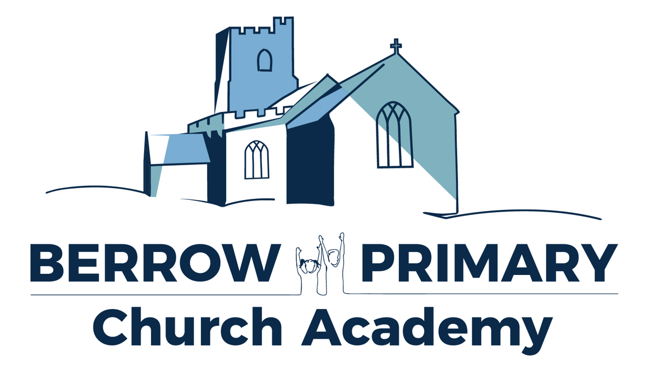

Berrow Primary Church Academy
Special Educational Needs Information Report

Date: July 2026
Review date: July 2027

The aim of our information report is to inform parents and carers about how we welcome, support and make effective provision to include children with special educational needs and/or disabilities (SEND). This report should be read in conjunction with the SEND policy which contains links to other agencies and Local Authority support.

Berrow Primary Church Academy is part of The Priory Learning Trust (TPLT) and includes our Little Learners Preschool where children are accepted from 2 years.

The school has clear and effective systems in place to identify and assess pupils’ individual needs early, including for those pupils with special educational needs and/or disabilities (SEND). (OFSTED April 26)

The head teacher, SENCO, and SLT have a clear and ambitious vision for inclusion evidenced through the SEND curriculum provision in the school. It is based on a culture of belonging alongside high aspiration for all pupils.(SEND review June 2025)

We embed the principles of the National Curriculum Inclusion Statement https://.gov.uk/government/collections/national-curriculum, by taking action to increase access to the curriculum, the environment and to printed information for all.

Pupils love attending this warm and welcoming inclusive school. (OFSTED April 26)

Pupils with SEND and their parents speak positively of the support they receive and outcomes achieved. Where appropriate, pupils are able to articulate how the support has made a difference to their learning and development. (SEND review June 2025)

SEND Support

We value and respect the achievements of all children and we will always listen to and involve parents and children in the planning and review of provision. We will ensure that pupils with SEN who attend our school can engage in the activities of the school alongside pupils who do not have SEN. In addition we will use our best endeavours to secure special educational provision for pupils for whom this is required, this includes everything that is “additional to and different from” that provided. This ensures all prime areas of SEN are fully supported.

- Communication and interaction,
- Cognition and learning,
- Social, emotional, mental health
- Sensory/physical

Children and young people with SEN are welcome to apply for a place at our school, in line with the school admissions policy. For children with an EHCP, parents have the right to request a particular school, including a special school, in order to meet their child's specific needs.

Our fully qualified staff comprises:
Principal: Miss Charlotte Bradley
SENCo: Mrs Kayleigh Cashman
Academic mentor: Miss Kelly Hunt

The school SENCo is contactable on 01278 783614 or senco@bpca.theplt.org.uk

Berrow School SEND profile
Across the school there are 14% of students with identified SEND needs

Type of support | Number of pupils September 2026
Special Education needs (SEN) support | 12
Education, health and care plan (EHCP) | 9
Types of SEND need at Berrow School

Broad area of need | Need type | Number of pupils September 2025 | Number of pupils September 2026
Cognition and Learning | Dyslexia  Literacy difficulties  Dyspraxia  Global developmental delay  Moderate/mild learning difficulty | 8 | 4
Communication and interaction | Autism Spectrum Disorder  Speech and language difficulty  Communication and interaction difficulty  Development language disorder  Stammer | 15 | 10
Social, Emotional and mental health | Attention deficit hyperactivity disorder (ADHD)  Attachment difficulties  ACES  Anxiety disorder  Obsessive compulsive disorder  Tourettes  Emotional difficulties  Other mental health challenges | 10 | 7
Physical and Sensory | Vision impairment  Hearing impairment  Multisensory impairment  Physical disability  Sensory processing difficulties  Cerebral palsy | 0 | 0

Question | Response
How does the school decide if my child needs extra help? | At our school we use the definition for SEN and for disability from the SEND Code of Practice (2014).  All pupils will be provided with high quality teaching that is differentiated to meet the needs of all learners. However, sometimes we recognise some pupils need more help than others in their class if they are to make good progress  At BPCA we know a child needs extra help if:  - Concerns are raised by parents/carers, external agencies, teachers, the child’s previous school or by the child themselves.  - Screening, such as that completed on entry or as a result of a concern being raised, indicates gaps in knowledge and/or skills.  - Whole school tracking of attainment outcomes indicates lack of expected rate of progress.  - Observation of the pupil indicates that they require additional support  Somerset Graduated Response Tool  Quality first teaching underpins all educational provision. It focuses on inclusive practice and breaks down barriers to learning. For the majority of children this can be achieved by identifying specific barriers, followed by personalisation and differentiation using strategies identified in the Somerset Graduated Response Tool. The Somerset Graduated Response Tool breaks down SEN into four broad areas of need. This targets specific support for teachers to plan and for any interventions to take place. You can learn more about the Somerset Graduated Response at: Somerset’s Graduated Response Tool  Discover more at Somerset’s SEND Local Offer and Somerset's SEND Local Offer | Taunton | Facebook
What should I do it I think my child has Special Educational Needs? | In the first instance, please talk to your child’s class teacher. Communication between school and families is key. We have a clear graduated response procedure we work with families on to ensure all are heard and needs are identified and subsequently met. This procedure will be ‘walked and talked’ through with families at every stage.  You may also be asked to complete a ‘Quick Checker’ to identify your areas of concern that you have to support your discussion with your child’s class teacher.
How will the school consult with me and how can I be involved in planning their support? | - All actions taken by the class teacher in the pupil profile will be recorded in Learning Passports and shared and reviewed alongside parents  - Parents are encouraged to arrange an appointment to discuss their child’s progress or any concerns with the class teacher and the SENCo.
How will my child be involved in planning the support they will have? | As a school, we aim to request, monitor and respond to our parents/carers and pupils' views in order to evidence high levels of confidence and partnership. We ensure a high level of staff expertise to meet pupil’s special educational needs, through well-targeted continuing professional development.
How do you know if my child is making progress? | Pupils’ attainments are tracked using the whole school tracking system, those who are not making expected levels of progress are identified quickly. These pupils are then discussed in termly pupil progress meetings between the class teacher and a member of the Senior Leadership team.  All pupils with SEND have individual targets set in line with national outcomes to ensure that they make progress. Parents are informed of these via the reporting system and also at events such as Learning Review Meetings.  Additional actions to increase the rate of progress will then be identified and recorded. This will include a review of any impact of the differentiated teaching being provided to the child, and if required, provision for additional strategies to further support success.  Where it is identified that special educational provision may be required, parents will be informed and their partnership sought in order to support the child to succeed.  The quality of classroom teaching provided to pupils with SEND is monitored through a number of processes that include:  - classroom observation by the SENCo or external verifiers,  - ongoing assessment of progress made by pupils with SEND,  - Scrutiny of Learning Passports and APDR documents  - teacher meetings with the SENCo to provide advice, training and guidance.  - attendance and behaviour records.
How will I be aware of my child’s progress? | The impact of our SEND support is measured by establishing a baseline at the start of in school Additional Provision and comparing to an exit assessment.  We evaluate what knowledge and understanding our children have gained and what they need to do next. Support is carefully planned to increase academic progress and build self-esteem.  Assess, Plan, Do, Review Targets are set out in Learning Passports, taking into account children’s learning needs, social and emotional wellbeing and any barriers to learning. The aim is for additional provision to be relevant and motivational:  “Study without desire spoils the memory, and it retains nothing that it takes in.” — Leonardo da Vinci  Targets and interventions are regularly reviewed and progress is recorded and assessed for impact.
How will the curriculum be matched to meet my child’s needs? | We follow a ‘Learning without limits’ approach, as such we believe that each child’s potential for learning is limitless and we will make reasonable adjustments and strive to reduce barriers so that all children can flourish and be successful.  The school receives funding to respond to the needs of pupils with SEND from a number of sources that includes:  1. A proportion of the funds allocated per pupil to the school to provide for their education called the Age Weighted Pupil Unit.  2.The National SEN budget. This is a fund devolved to schools to support them to meet the needs of pupils with SEND.  3. For those pupils with the most complex needs who have EHCP, the school may be allocated additional educational needs funding from the Local Authorities High Needs SEN Funding allocation Top Up Funding (TUF).
How will information about my child’s special educational needs or disability and the support they will need be communicated to staff? | We ensure a high level of staff expertise to meet pupil’s special educational needs, through well-targeted continuing professional development and communication between teams.
What training do teachers at Berrow receive about working with children with SEND? | The school has access to a range of specialist support and in the last two years school staff have received a range of training on:  - Youth Mental Health First Aid  - Nurture UK principles  - ELSA (Emotional Literacy Support Assistant)  - FASD (Foetal Alcohol Spectrum Disorder)  - High Incidence  - How to support pupils with dyslexia and literacy difficulties.  - How to support children with ADHD  - Anxiety ~ Bridging the Gap.  - Emotion coaching  - Sensory Processing Awareness  - Supporting pupils with trauma  - How to support pupils on the autistic spectrum  - How to support pupils with behavioural difficulties  - Supporting pupils with speech, language and communication difficulties  - Oracy ~ closing the gap  - Precision teaching  - Numicon Supporting mathematics  - Supporting children with dyslexia  The school also makes use of support from external services such as  - SEN specialists  - Educational Psychologist
What support outside of the classroom could my child receive? | Examples of some alternative provision provided by BPCA and their success  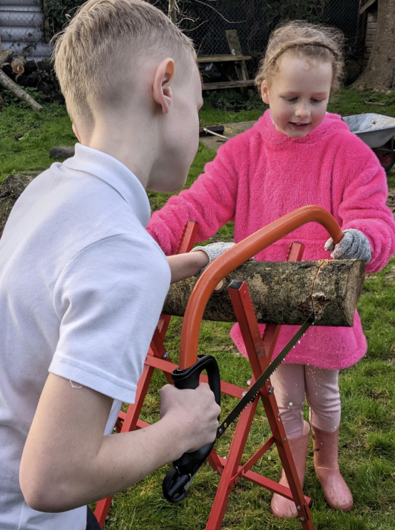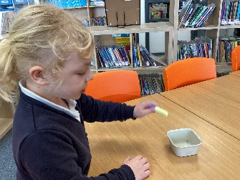
  Alternative provision | Impact
  Time2Talk –Small group activities to develop oral language and social interaction skills | Children develop confidence in their oracy skills which impacts on their ability to access all areas of the curriculum.
  Go noodle – movement and motor skills group | Children are building their fine and gross motor skills which are supporting them in the classroom and in their wider lives.
  Precision teaching | Children who do find phonics difficult have other strategies to draw on.
  Forest school | Children grow in confidence in their own ability and learn life skills such as problem solving, trust and team work.
What specialist services and expertise are available at or access by the school and how do you all work together? | All SEN support will follow an Assess, Plan, Do and Review model (APDR).  If progress rates are still low, despite the delivery of high quality school based interventions, advice will always be sought from external agencies regarding strategies to best meet the specific needs. This will only be undertaken after parent permission has been obtained and may include referral to:  1. Local Authority Support Services  2. Specialists in other schools e.g. teaching schools, special schools.  3. Social Services  4. Health partners such as the School Nursing Service  For a very small percentage of pupils, whose needs are significant and complex and cannot be met through the school’s own resources, a request can be made to the local authority to conduct an assessment of education, health care needs. This may result in an Education, Health Care (EHC) plan being provided.  Berrow Primary Church Academy is a Mental Health support team (MHST) school striving to support all children’s mental health and wellbeing.  Alongside this the school offers a wide variety of pastoral support for pupils. This includes:  - An evaluated Personal, Social, Emotional Development (PSED) curriculum to help pupils with the knowledge, understanding and skills they need to enhance their emotional and social knowledge and well-being. Please visit our website to see the topics that are included within this area of the curriculum.  - Pupil and Parent voice mechanisms are in place and are monitored for effectiveness by the SENCO.  Pupils with medical needs will be provided with an Individual Health Care Plan, compiled in partnership with the SENCo and parents and, when possible, health care professionals. If appropriate, the pupil themselves will contribute to the plan.  We aim to support children with medical conditions to achieve full inclusion in all school activities by ensuring consultation with health and social care professionals. We work in cooperative and productive partnership with the Local Authority and other outside agencies, to ensure there is a multi-professional approach to meeting the needs of all vulnerable learners.  Berrow uses pupil centred profiles, ‘All about me’. These are completed by the pupils themselves with the support of a member of staff who knows the child well. Together they will identify the child’s abilities and strengths, their personal aims and the action needed to be taken by the school to reduce barriers to learning and social success.
How will my child be included in activities outside the classroom including extracurricular clubs and school trips? | Children on the SEN register will be supported in activities, school trips and camps through:  - Comprehensive risk assessments  - Seeking timely outside agency advice  - In depth staff training and knowledge of pupils.  - Reasonable adjustments to overcome any challenges.
How accessible is the school environment? | Over the last 3 years our site has been developed to give our pupils even more opportunities. We now have:  - Disabled parking spots  - The Learning Den to provide a quiet learning space  - The Little Learners preschool is fully accessible to all  - Outside areas have been updated and resources replaced.  - The sensory room has had an upgrade and is now being enjoyed by all.  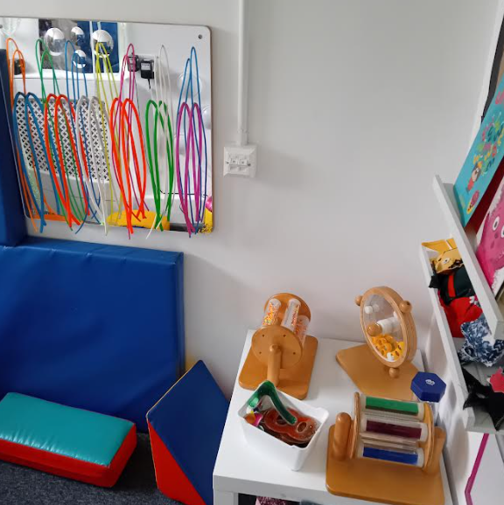  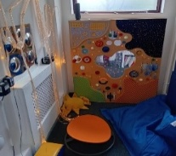  
How will the school prepare and support my child to join the school, transfer to a new setting/school/college or for the next stage of education and life? | Additional support for pupils with SEN is provided for all points of transition. As a result, pupils with SEND are well prepared for their next phase of education. The early years provision aligns with the rest of the school so that the entry into reception is seamless. (SEND review June 2025)  Our transition process includes:  - A planned introduction programme delivered in the summer term to support the transfer for children starting in EYFS Reception including additional sessions for children with SEN.  - Parents/carers are invited to attend a meeting at the school and are provided with a range of information to support them in enabling their child to settle into the school routine.  - The SENCo is available to meet with any new parents of children who are known to have or suspected to have SEND.  - Children transferring from another setting, will have all records requested immediately and a meeting set up with parents and the child to identify and reduce any concerns.  - Transition to the next school phase is supported by a transition programme for pupils. It provides a number of opportunities for children and parents to meet staff in the new school. These opportunities are further enhanced for pupils with SEND.  - The annual review in Y5 for children with an EHCP begins the process where parents are supported to make decisions regarding secondary school choice.  - For pupils transferring to local schools, the SENCos and/or class teachers of both schools will meet to discuss the needs of pupils with SEN in order to ensure a smooth transition.
If I am not happy with the support my child is getting, what should I do? | If you wish to discuss your child’s special educational needs, or are unhappy about any issues regarding the school’s response to meeting these needs please contact the following:  - Your child’s class teacher,  - The SENCo, Mrs Kayleigh Cashman  - Principal, Miss Charlotte Bradley  - For complaints, please contact the Community Councillor with responsibility for SEN who can be contacted via the school office.( office@bpca.theplt.org.uk )
Who can I contact for further information? | TPLT Policies Page: https://www.theplt.org.uk/page/?title=Policies&pid=43  Support services for parents of pupils with SEN include Supportive Parents, National Dyslexia Society, MENCAP, Child Autism, The National Autistic Society and Talking Point. For parents who are unhappy with the Local Authority or school responses to their child’s SEND, parents may seek mediation from the regional mediation services. Information on this free service is located here http://preview.tinyurl.com/qx5a8vq  Information on where the Local Authority’s Local Offer can be found at: https://professionalchoices.org.uk/eha/  Support for families and young people.  - https://somersetsafeguardingchildren.org.uk/  - https://somersetparentcarerforum.org.uk/home/wise-up-workshops/  - Wise up workshops - empowering parent carers to succeed  - https://www.somersetbigtent.org.uk/  - https://hubofhope.co.uk/  - https://www.josephinesstar.org.uk/  - https://www.youngsomerset.org.uk/  - https://somewherehousesomerset.org/

Glossary of acronyms relating to SEND support

Parent Family Support Advisors (PFSA):
Parent and Family Support Advisors (PFSAs) work with school-aged children and their families that require additional support.
Family Intervention Service (FIS):
FIS worker – the lead professional assigned to support the family
The Family Intervention Service (FIS) is a specialist county-wide service that offers support to children and young people from birth up to 18 years and their families where multiple complex issues are present.
Young Carers (YC):
This service is part of the Family Intervention Service. They support children and young people (YP) who provide a caring role for a member of their family
Team Around the Family (TAF):
The professionals who work with the family to identify need, plan interventions and meet regularly to review progress. TAF meetings are held by PFSA and FIS and should continue for a short time with school once these services have closed their intervention.
Children’s Social Care (CSC) :
Level 4 service for families with the highest needs and when there is significant risk of harm
Child Looked After (CLA) :
A child who is in the care of a foster family.
Children and Family Court Advisory and Support Service (CAFCASS):
CAFCASS represent children in family court cases. An advocate is appointed to gain the views of the children.
Early Help Assessment (EHA):
This is completed with the family, detailing their needs and forms the basis of a referral. It can be added to by all professionals involved.

Welcome to Berrow Primary Church Academy. We are one big family.



